### **REST API Usage Documentation**

This project provides three REST APIs. Below are the details on how to interact with them:

#### **1. Get JWT via Login (POST API)**

* **URL:** http://localhost:8888/onecom/wp-json/storefront/v1/login
* **Description:** This API allows users to log in and obtain a JWT token for authentication.

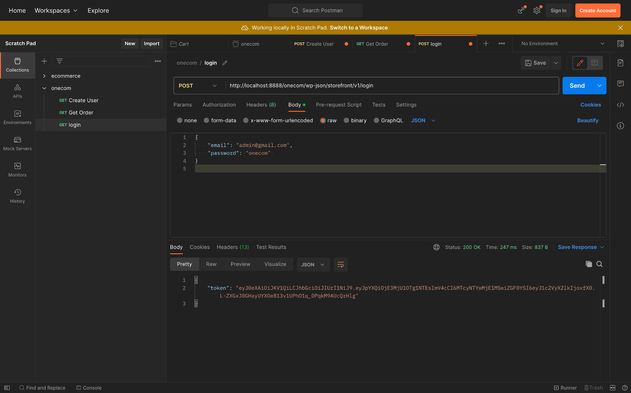

#### **2. Fetch Orders (GET API)**

* **URL: http://localhost:8888/onecom/wp-json/storefront/v1/get-orders**
* **Description:** This API retrieves a list of all orders.

**Headers:**

* **Authorization:** Include the JWT token from the login API in the Authorization header.

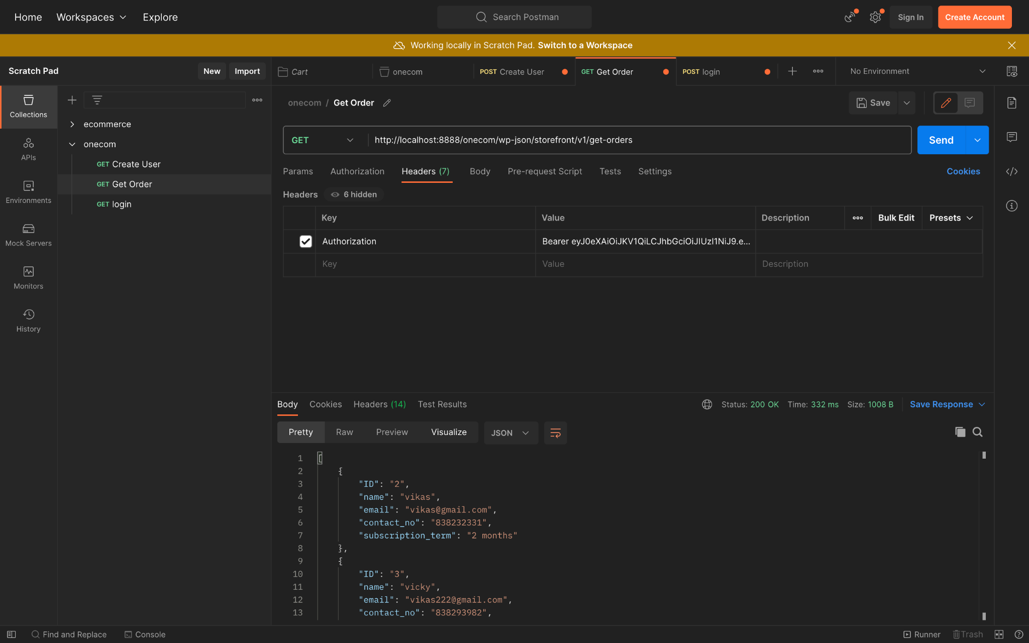

#### **3. Submit Data (POST API)**

* **URL: http://localhost:8888/onecom/wp-json/storefront/v1/submit-data**
* **Description:** This API allows you to create a user.

